Questions/Main ideas:
______________________________________________________________________________________________________________________________________________________________________________________________________________________________________________________________________________________________________________________________________________________________________________________________________________________________________________________________________________________________________________________________________________________________________________________________________________________________________________________________________________________________________________________________________________________________________________________________________________________________________________________________________________________________________________________________________________________
Summary:

Notes:

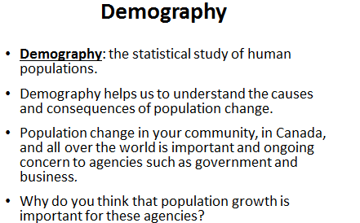
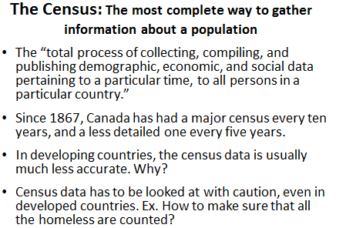

Questions/Main ideas:
______________________________________________________________________________________________________________________________________________________________________________________________________________________________________________________________________________________________________________________________________________________________________________________________________________________________________________________________________________________________________________________________________________________________________________________________________________________________________________________________________________________________________________________________________________________________________________________________________________________________________________________________________________________________________________________________________________________
Summary:

Notes:

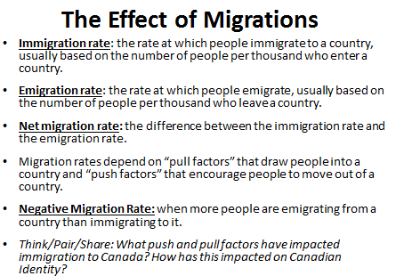
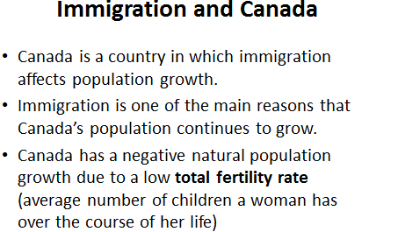

Questions/Main ideas:
______________________________________________________________________________________________________________________________________________________________________________________________________________________________________________________________________________________________________________________________________________________________________________________________________________________________________________________________________________________________________________________________________________________________________________________________________________________________________________________________________________________________________________________________________________________________________________________________________________________________________________________________________________________________________________________________________________________Summary:

Notes:
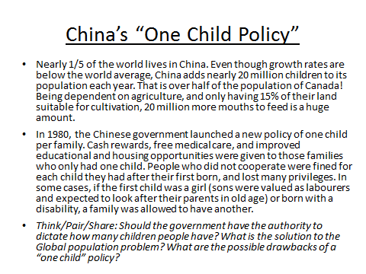
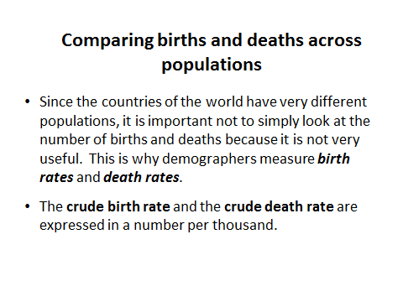

Questions/Main ideas:
______________________________________________________________________________________________________________________________________________________________________________________________________________________________________________________________________________________________________________________________________________________________________________________________________________________________________________________________________________________________________________________________________________________________________________________________________________________________________________________________________________________________________________________________________________________________________________________________________________________________________________________________________________________________________________________________________________________
Summary:

Notes:
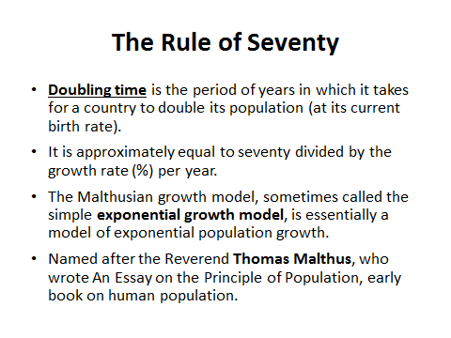
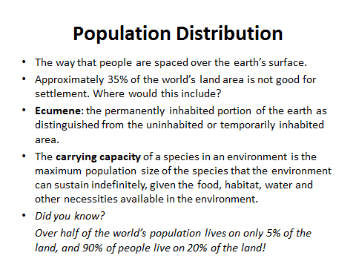

Questions/Main ideas:
______________________________________________________________________________________________________________________________________________________________________________________________________________________________________________________________________________________________________________________________________________________________________________________________________________________________________________________________________________________________________________________________________________________________________________________________________________________________________________________________________________________________________________________________________________________________________________________________________________________________________________________________________________________________________________________________________________________
Summary:

Notes:
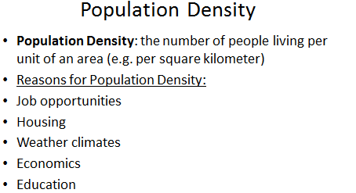
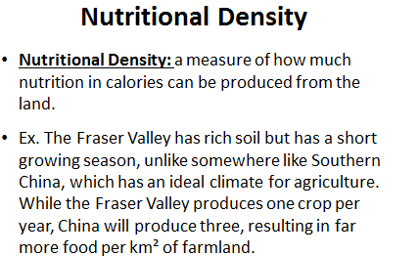
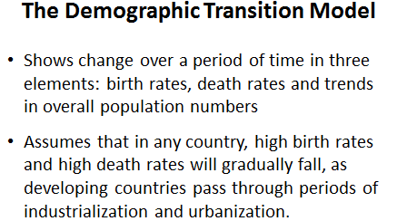

Questions/Main ideas:
_____________________________________________________________________________________________________________________________________________________________________________________________________________________________________________________________________________________________________________________________________________________________________________________________________________________________________________________________________________________________________________________________________________________________________________________________________________________________________________________________________________________________________________________________________________________________________________________________________________________________________________________________________________________________________________________________________________________
Summary:

Notes:
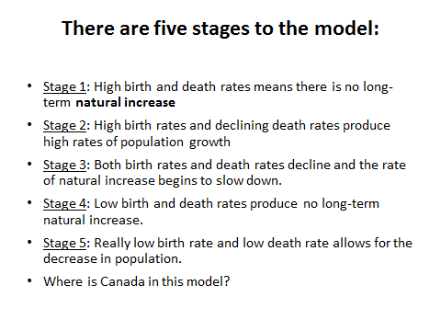
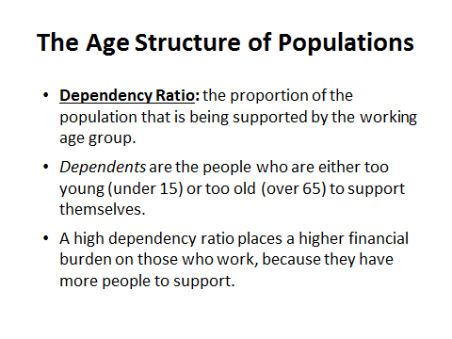

Questions/Main ideas:
______________________________________________________________________________________________________________________________________________________________________________________________________________________________________________________________________________________________________________________________________________________________________________________________________________________________________________________________________________________________________________________________________________________________________________________________________________________________________________________________________________________________________________________________________________________________________________________________________________________________________________________________________________________________________________________________________________________
Summary:

Notes:
