Questions/Main ideas:
______________________________________________________________________________________________________________________________________________________________________________________________________________________________________________________________________________________________________________________________________________________________________________________________________________________________________________________________________________________________________________________________________________________________________________________________________________________________________________________________________________________________________________________________________________________________________________________________________________________________________________________________________________________________________________________________________________________
Summary:

Notes:

Aboriginal Issues
- Aboriginal traditions hold that the First Nations were created in North America, and have always been here. Various other theories suggest that they migrated across a land bridge from Siberia between 20 000 and 10 000 BCE, or came from Asia in rafts.
- Whatever their origins, the Aboriginals formed many national groups. It is estimated that when the first Europeans arrived in North America, there were approximately 220 000 Aboriginal people living in what is now Canada.
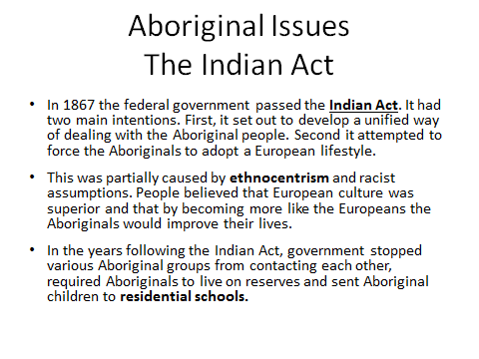

Questions/Main ideas:
______________________________________________________________________________________________________________________________________________________________________________________________________________________________________________________________________________________________________________________________________________________________________________________________________________________________________________________________________________________________________________________________________________________________________________________________________________________________________________________________________________________________________________________________________________________________________________________________________________________________________________________________________________________________________________________________________________________
Summary:

Notes:
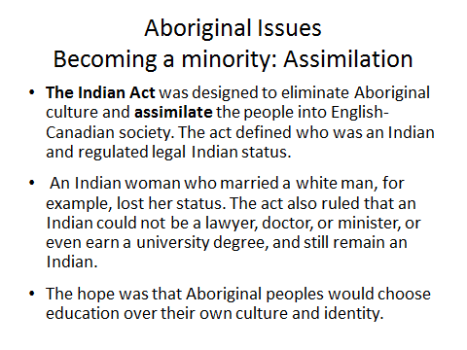
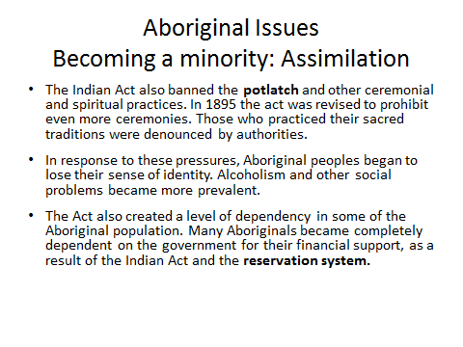

Questions/Main ideas:
______________________________________________________________________________________________________________________________________________________________________________________________________________________________________________________________________________________________________________________________________________________________________________________________________________________________________________________________________________________________________________________________________________________________________________________________________________________________________________________________________________________________________________________________________________________________________________________________________________________________________________________________________________________________________________________________________________________
Summary:

Notes:
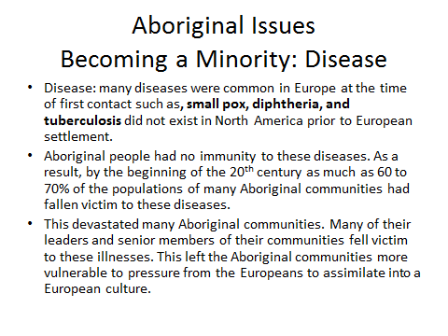
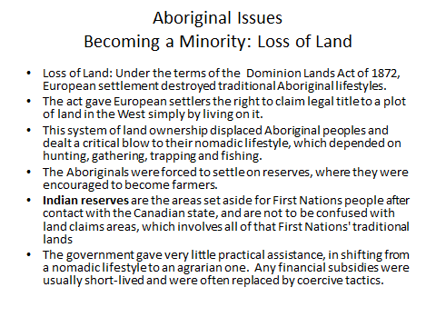

Questions/Main ideas:
______________________________________________________________________________________________________________________________________________________________________________________________________________________________________________________________________________________________________________________________________________________________________________________________________________________________________________________________________________________________________________________________________________________________________________________________________________________________________________________________________________________________________________________________________________________________________________________________________________________________________________________________________________________________________________________________________________________
Summary:

Notes:
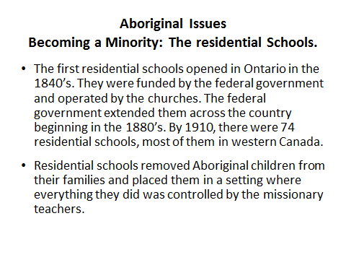
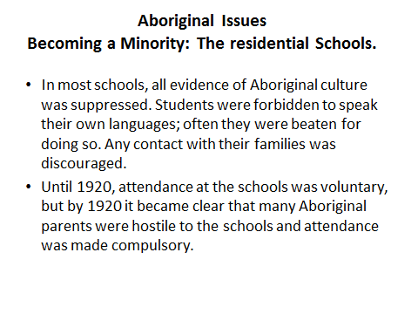

Questions/Main ideas:
______________________________________________________________________________________________________________________________________________________________________________________________________________________________________________________________________________________________________________________________________________________________________________________________________________________________________________________________________________________________________________________________________________________________________________________________________________________________________________________________________________________________________________________________________________________________________________________________________________________________________________________________________________________________________________________________________________________
Summary:

Notes:
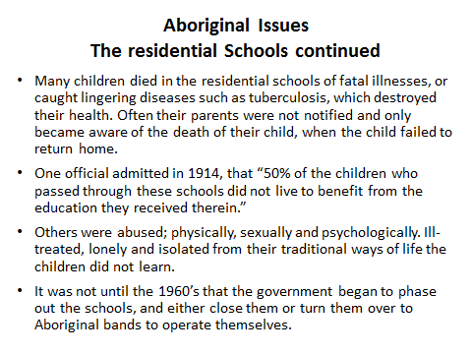
Aboriginal Issues
The residential Schools continued
- In 1992, a report by the Royal Commission on Aboriginal Peoples blamed residential schools for contributing to the high rates of substance abuse, suicide and family problems among Aboriginal peoples.
- In January 1998, the federal government issued an apology to Aboriginal peoples and expressed regret over residential schools. They offered 350$ million for victims of the schools, to be used for community projects.
- Many Aboriginals thought this was too little too late. Families had been destroyed, children grew up being parented by institutions, leaving them ill-prepared to parent their own children and some aspects of Aboriginal culture became almost impossible to maintain.

Questions/Main ideas:
______________________________________________________________________________________________________________________________________________________________________________________________________________________________________________________________________________________________________________________________________________________________________________________________________________________________________________________________________________________________________________________________________________________________________________________________________________________________________________________________________________________________________________________________________________________________________________________________________________________________________________________________________________________________________________________________________________________
Summary:

Notes:
Today’s Plan Stage 1
- Free write response: 10 minutes
- A. Answer the following: In your own opinion do you think the government should have been involved in the education of the Aboriginal children? Why or Why not?
- B. Share your response with your neighbor. Where do you agree? Where do you differ?
- C. Be ready to share your response if called on in class.
Today’s plan Stage 2
- Responding to a Report (20 min)
- A) In partners, students will read an excerpt from a handout which is actually a primary source from 1816. This is an unedited document, which has been photocopied.
- B) Answer the following questions on a blank piece of paper:
- 1. Who do you think may have written this?
- 2. Name three assumptions the author has about the aboriginal peoples.
- 3. In what ways did this document accurately depict how the residential school system would be setup 50 years later?

Questions/Main ideas:
______________________________________________________________________________________________________________________________________________________________________________________________________________________________________________________________________________________________________________________________________________________________________________________________________________________________________________________________________________________________________________________________________________________________________________________________________________________________________________________________________________________________________________________________________________________________________________________________________________________________________________________________________________________________________________________________________________________
Summary:

Notes:
Aboriginal Issues: The Allied Tribes
- The Federal Government always expected that the Aboriginal population would eventually assimilate into white society.
- After WWI it became clear that the Aboriginals themselves did not wish to be assimilated.
- The Allied Tribes of BC was founded in June of 1916. Its main goal was to settle Aboriginal land claims.
- In most provinces, colonial authorities had eliminated the possibility of Aboriginal land claims by signing treaties.
- BC did not do this. When the McKenna-McBride Commission on Indian Affairs recommended a reduction in the size of many reserves in BC the Allied Tribes responded with a “comprehensive” land claim. It was rejected by the federal government.
- In response the government passed legislation based on the commission’s recommendations, this included Bill 14, which called for the automatic enfranchisement of Aboriginal war veterans, and the ultimate assimilation of the Aboriginal people into white society.
The Allied Tribes, Continued
- The Aboriginal peoples did not want to assimilate or be forced to assimilate with white culture. They also wanted larger portions of land set aside for their use.
- The Allied Tribes decided to present its case to the Privy Council in London. In 1926, a delegation of the Allied Tribes went to London with a petition demanding similar treatment to the resolution achieved by an Aboriginal group in Nigeria in 1921 that had retained its title to its traditional land because they had never signed a treaty.
- The final paragraph of the petition to the Privy Council stated that “We do not want enfranchisement, we want to be Indian to the end of the World”
- The delegation was intercepted by the head of the Canadian High Commission in London, who promised to deliver the petition to the proper authorities. That was the end of the mission to London.

Questions/Main ideas:
______________________________________________________________________________________________________________________________________________________________________________________________________________________________________________________________________________________________________________________________________________________________________________________________________________________________________________________________________________________________________________________________________________________________________________________________________________________________________________________________________________________________________________________________________________________________________________________________________________________________________________________________________________________________________________________________________________________
Summary:

Notes:
The Allied Tribes: The injustice continues
- When they returned from London the Allied Tribes found the Government willing to talk to them. However, this would prove short lived, when they met in the Spring of 1927 with Scott (administrator of the Dept. of Indian affairs) he said their demands would “Smash confederation.” This essentially ended negotiations until the 1970’s.
- The government then passed a law that made it illegal for anyone to solicit funds for the purpose of pursuing land claims. Other restrictions were placed on the right of Aboriginal peoples to assemble.
- This was essentially the end of the Allied Tribes which collapsed that same year. It is, after all, hard to maintain an organization, when it is illegal for your organization to meet.
Aboriginal Issues
From the White Paper into the future
- In 1969 the government presented a proposed piece of legislation called the White Paper.
- This paper was based on the philosophy that Aboriginal peoples should be assimilated into the Canadian population.
- This meant that the Aboriginals would have complete equality, with no special privileges based on their Aboriginal status.
- To achieve this, the government proposed to abolish the Department of Indian Affairs, eliminate the reserve system, turn over responsibility for the Aboriginal peoples to the provincial governments and terminate “Indian” status.

Questions/Main ideas:
______________________________________________________________________________________________________________________________________________________________________________________________________________________________________________________________________________________________________________________________________________________________________________________________________________________________________________________________________________________________________________________________________________________________________________________________________________________________________________________________________________________________________________________________________________________________________________________________________________________________________________________________________________________________________________________________________________________
Summary:

Notes:
Aboriginal Issues
From the White Paper into the future
- This was done with minimal consultation with the Aboriginal population.
- The Aboriginal communities did not want to be assimilated. They did not want to lose their special status. They felt that the government was trying to get out of its responsibility to Aboriginal peoples as compensation for the lands that had been taken from them.
- In face of this opposition, the government withdrew the White paper and agreed to begin negotiations with Aboriginal peoples.
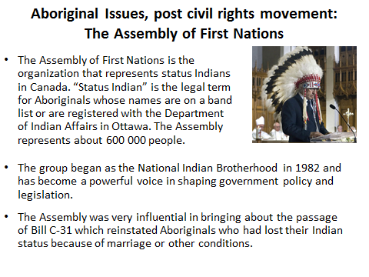

Questions/Main ideas:
______________________________________________________________________________________________________________________________________________________________________________________________________________________________________________________________________________________________________________________________________________________________________________________________________________________________________________________________________________________________________________________________________________________________________________________________________________________________________________________________________________________________________________________________________________________________________________________________________________________________________________________________________________________________________________________________________________________
Summary:

Notes:
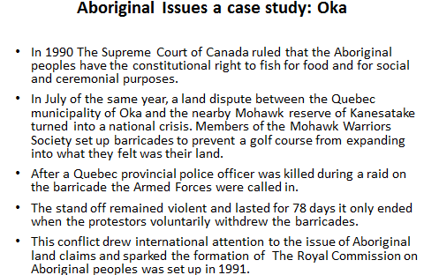

Aboriginal Issues a case study: Oka
- In 1990 The Supreme Court of Canada ruled that the Aboriginal peoples have the constitutional right to fish for food and for social and ceremonial purposes.
- In July of the same year, a land dispute between the Quebec municipality of Oka and the nearby Mohawk reserve of Kanesatake turned into a national crisis. Members of the Mohawk Warriors Society set up barricades to prevent a golf course from expanding into what they felt was their land.
- After a Quebec provincial police officer was killed during a raid on the barricade the Armed Forces were called in.
- The standoff remained violent and lasted for 78 days it only ended when the protestors voluntarily withdrew the barricades.
- This conflict drew international attention to the issue of Aboriginal land claims and sparked the formation of The Royal Commission on Aboriginal peoples was set up in 1991.

Questions/Main ideas:
______________________________________________________________________________________________________________________________________________________________________________________________________________________________________________________________________________________________________________________________________________________________________________________________________________________________________________________________________________________________________________________________________________________________________________________________________________________________________________________________________________________________________________________________________________________________________________________________________________________________________________________________________________________________________________________________________________________
Summary:

Notes:
Aboriginal Issues: Self Government
- Self-government is the right of the Aboriginal peoples to govern themselves, in their own communities.
- In 1983 a committee of the federal Parliament said that Aboriginal societies “form a distinct order of government in Canada.”
- There are different forms of self-government. Ex. In 1986, the Sechelt First Nation in BC became the first band in Canada to achieve a form of self-government. The Sechelt Government Indian District has powers similar to those of a municipality.
- The Sechelt Act created the Sechelt Band as a legal entity.
- In northern Canada where Aboriginal peoples form the majority, another form of self-government was applied.
- In April of 1999 the new territory of Nunavut was created and is completely controlled by the Inuit, with the territorial government exercising many of the powers of a province.
Aboriginal Issues: Land Claims
- Aboriginal land claims have been of two types.
- Specific claims: Refer to areas where treaties between Aboriginal peoples and the federal government have been signed, but their terms have not been kept. Ex. The agreed-upon size of a reserve may have decreased as land was taken away for the building of a highway or other development.
- Comprehensive claims: These question the ownership of land in large parts of Canada that were never surrendered by treaty.

Questions/Main ideas:
______________________________________________________________________________________________________________________________________________________________________________________________________________________________________________________________________________________________________________________________________________________________________________________________________________________________________________________________________________________________________________________________________________________________________________________________________________________________________________________________________________________________________________________________________________________________________________________________________________________________________________________________________________________________________________________________________________________
Summary:

Notes:
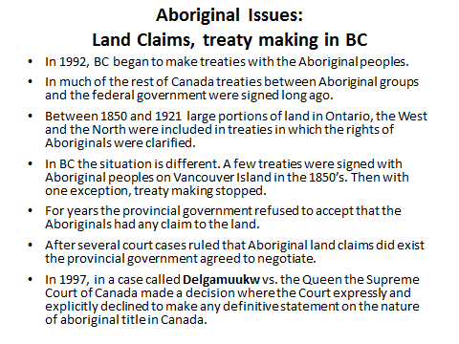
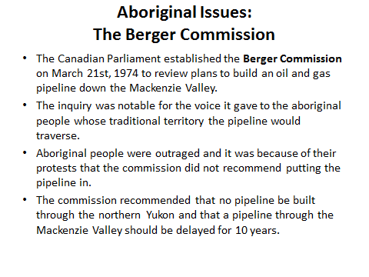

Questions/Main ideas:
______________________________________________________________________________________________________________________________________________________________________________________________________________________________________________________________________________________________________________________________________________________________________________________________________________________________________________________________________________________________________________________________________________________________________________________________________________________________________________________________________________________________________________________________________________________________________________________________________________________________________________________________________________________________________________________________________________________
Summary:

Notes:
