Questions/Main ideas:
______________________________________________________________________________________________________________________________________________________________________________________________________________________________________________________________________________________________________________________________________________________________________________________________________________________________________________________________________________________________________________________________________________________________________________________________________________________________________________________________________________________________________________________________________________________________________________________________________________________________________________________________________________________________________________________________________________________
Summery:

Notes:
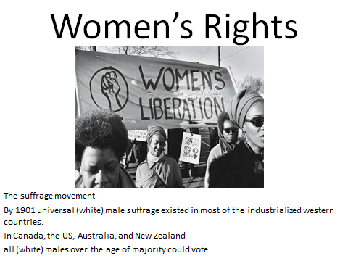
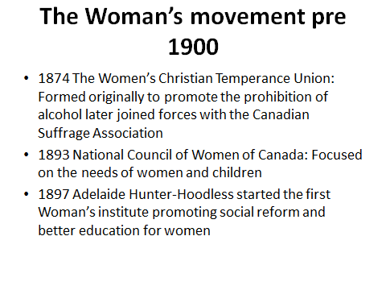

Questions/Main ideas:
______________________________________________________________________________________________________________________________________________________________________________________________________________________________________________________________________________________________________________________________________________________________________________________________________________________________________________________________________________________________________________________________________________________________________________________________________________________________________________________________________________________________________________________________________________________________________________________________________________________________________________________________________________________________________________________________________________________
Summery:

Notes:
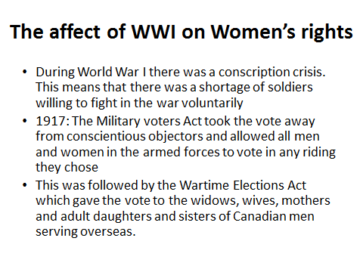
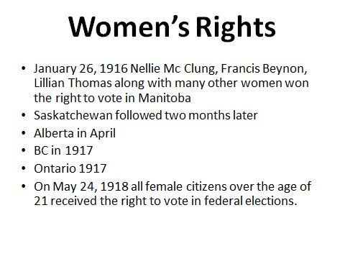

Questions/Main ideas:
______________________________________________________________________________________________________________________________________________________________________________________________________________________________________________________________________________________________________________________________________________________________________________________________________________________________________________________________________________________________________________________________________________________________________________________________________________________________________________________________________________________________________________________________________________________________________________________________________________________________________________________________________________________________________________________________________________________Summery:

Notes:
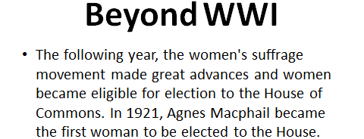
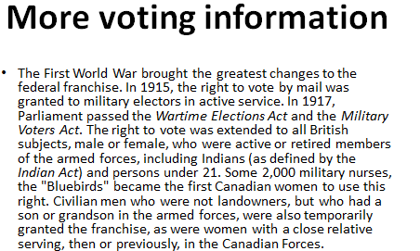
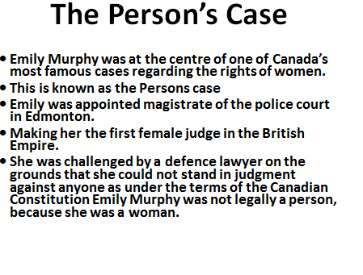

Questions/Main ideas:
______________________________________________________________________________________________________________________________________________________________________________________________________________________________________________________________________________________________________________________________________________________________________________________________________________________________________________________________________________________________________________________________________________________________________________________________________________________________________________________________________________________________________________________________________________________________________________________________________________________________________________________________________________________________________________________________________________________Summery:

Notes:
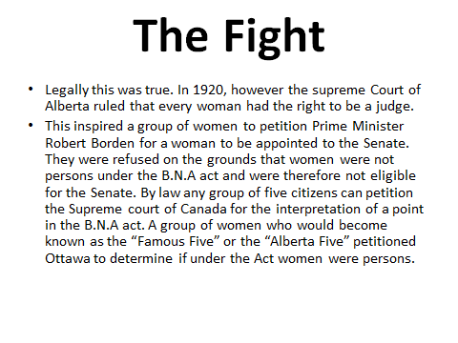
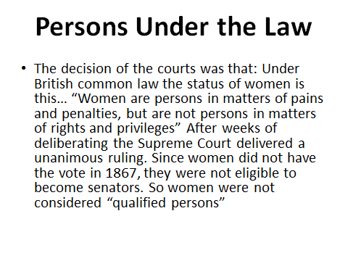

Questions/Main ideas:
______________________________________________________________________________________________________________________________________________________________________________________________________________________________________________________________________________________________________________________________________________________________________________________________________________________________________________________________________________________________________________________________________________________________________________________________________________________________________________________________________________________________________________________________________________________________________________________________________________________________________________________________________________________________________________________________________________________Summery:

Notes:
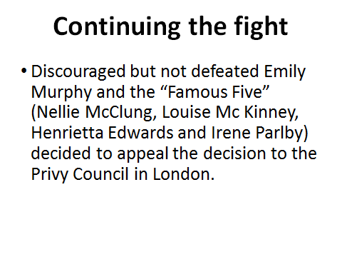
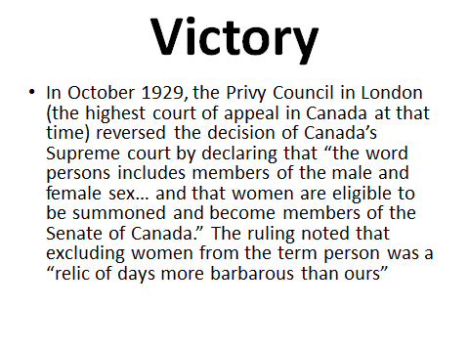

Questions/Main ideas:
______________________________________________________________________________________________________________________________________________________________________________________________________________________________________________________________________________________________________________________________________________________________________________________________________________________________________________________________________________________________________________________________________________________________________________________________________________________________________________________________________________________________________________________________________________________________________________________________________________________________________________________________________________________________________________________________________________________Summery:

Notes:
