Questions/Main ideas:
______________________________________________________________________________________________________________________________________________________________________________________________________________________________________________________________________________________________________________________________________________________________________________________________________________________________________________________________________________________________________________________________________________________________________________________________________________________________________________________________________________________________________________________________________________________________________________________________________________________________________________________________________________________________________________________________________________________
Summary:

Notes:

Questions/Main ideas:
______________________________________________________________________________________________________________________________________________________________________________________________________________________________________________________________________________________________________________________________________________________________________________________________________________________________________________________________________________________________________________________________________________________________________________________________________________________________________________________________________________________________________________________________________________________________________________________________________________________________________________________________________________________________________________________________________________________
Summary:

Notes:

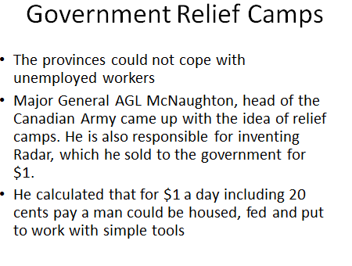

Questions/Main ideas:
______________________________________________________________________________________________________________________________________________________________________________________________________________________________________________________________________________________________________________________________________________________________________________________________________________________________________________________________________________________________________________________________________________________________________________________________________________________________________________________________________________________________________________________________________________________________________________________________________________________________________________________________________________________________________________________________________________________
Summary:

Notes:

Questions/Main ideas:
______________________________________________________________________________________________________________________________________________________________________________________________________________________________________________________________________________________________________________________________________________________________________________________________________________________________________________________________________________________________________________________________________________________________________________________________________________________________________________________________________________________________________________________________________________________________________________________________________________________________________________________________________________________________________________________________________________________
Summary:

Notes:

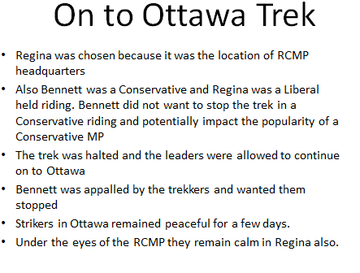

Questions/Main ideas:
______________________________________________________________________________________________________________________________________________________________________________________________________________________________________________________________________________________________________________________________________________________________________________________________________________________________________________________________________________________________________________________________________________________________________________________________________________________________________________________________________________________________________________________________________________________________________________________________________________________________________________________________________________________________________________________________________________________
Summary:

Notes:
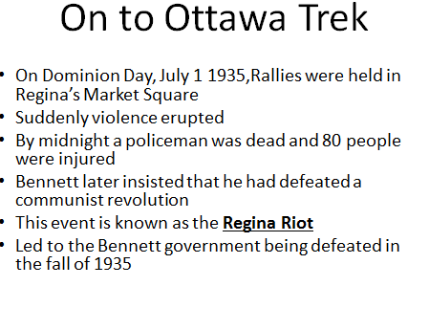
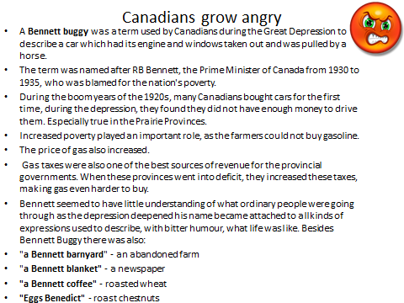

Questions/Main ideas:
______________________________________________________________________________________________________________________________________________________________________________________________________________________________________________________________________________________________________________________________________________________________________________________________________________________________________________________________________________________________________________________________________________________________________________________________________________________________________________________________________________________________________________________________________________________________________________________________________________________________________________________________________________________________________________________________________________________
Summary:

Notes:
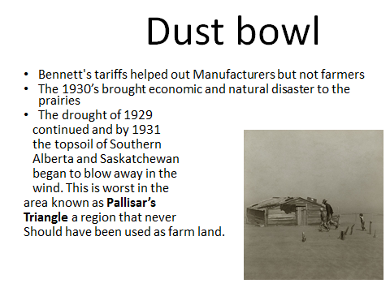
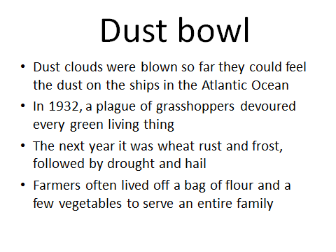

Questions/Main ideas:
______________________________________________________________________________________________________________________________________________________________________________________________________________________________________________________________________________________________________________________________________________________________________________________________________________________________________________________________________________________________________________________________________________________________________________________________________________________________________________________________________________________________________________________________________________________________________________________________________________________________________________________________________________________________________________________________________________________
Summary:

Notes:
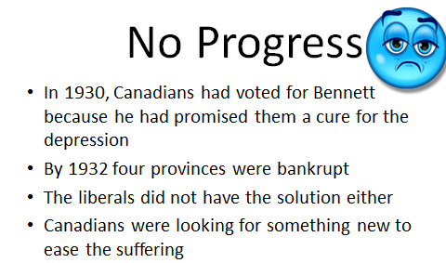
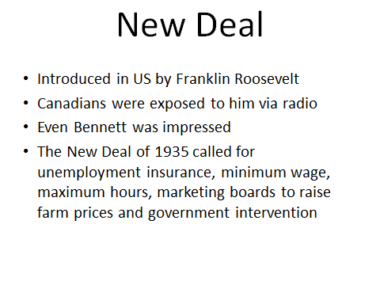

Questions/Main ideas:
______________________________________________________________________________________________________________________________________________________________________________________________________________________________________________________________________________________________________________________________________________________________________________________________________________________________________________________________________________________________________________________________________________________________________________________________________________________________________________________________________________________________________________________________________________________________________________________________________________________________________________________________________________________________________________________________________________________
Summary:

Notes:
